CaseManagement_CreationOfCase_Instance23_03-Aug-2018_08-13-44_AM_SingleSignOn.png

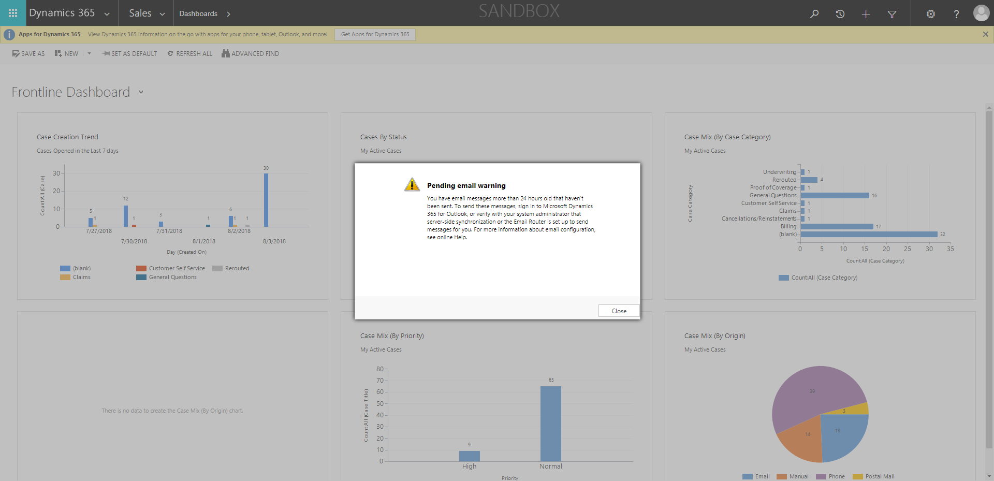

CaseManagement_CreationOfCase_Instance23_03-Aug-2018_08-13-19_AM_MouseClickActiononStaleElement.png

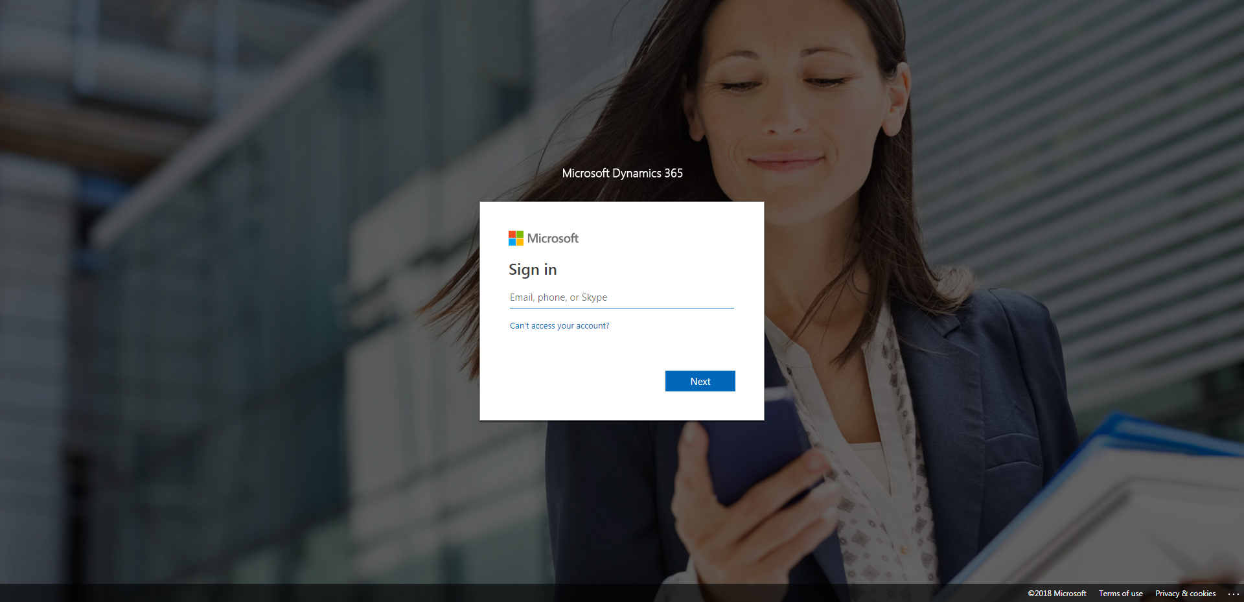

CaseManagement_CreationOfCase_Instance23_03-Aug-2018_08-13-51_AM_MouseClickActionMoveToElementBycssSelectorspanTabSFA.png

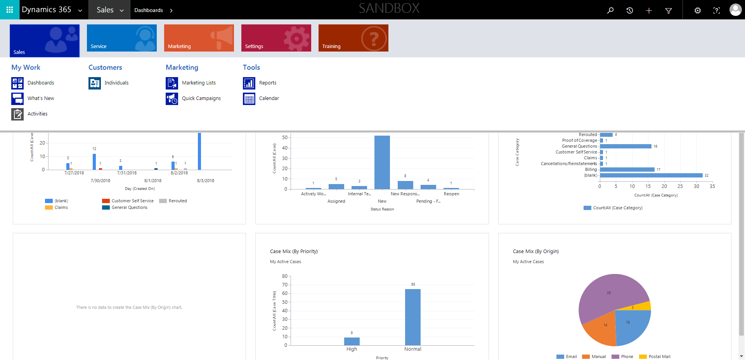

CaseManagement_CreationOfCase_Instance23_03-Aug-2018_08-13-22_AM_MouseClickActiononStaleElement.png

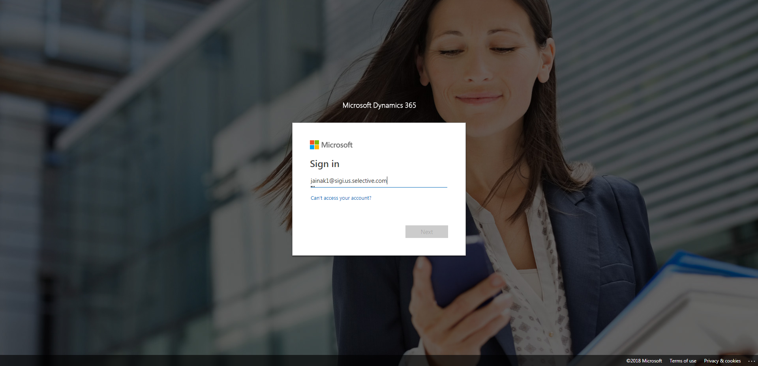

CaseManagement_CreationOfCase_Instance23_03-Aug-2018_08-13-21_AM_EnterTextAction.png

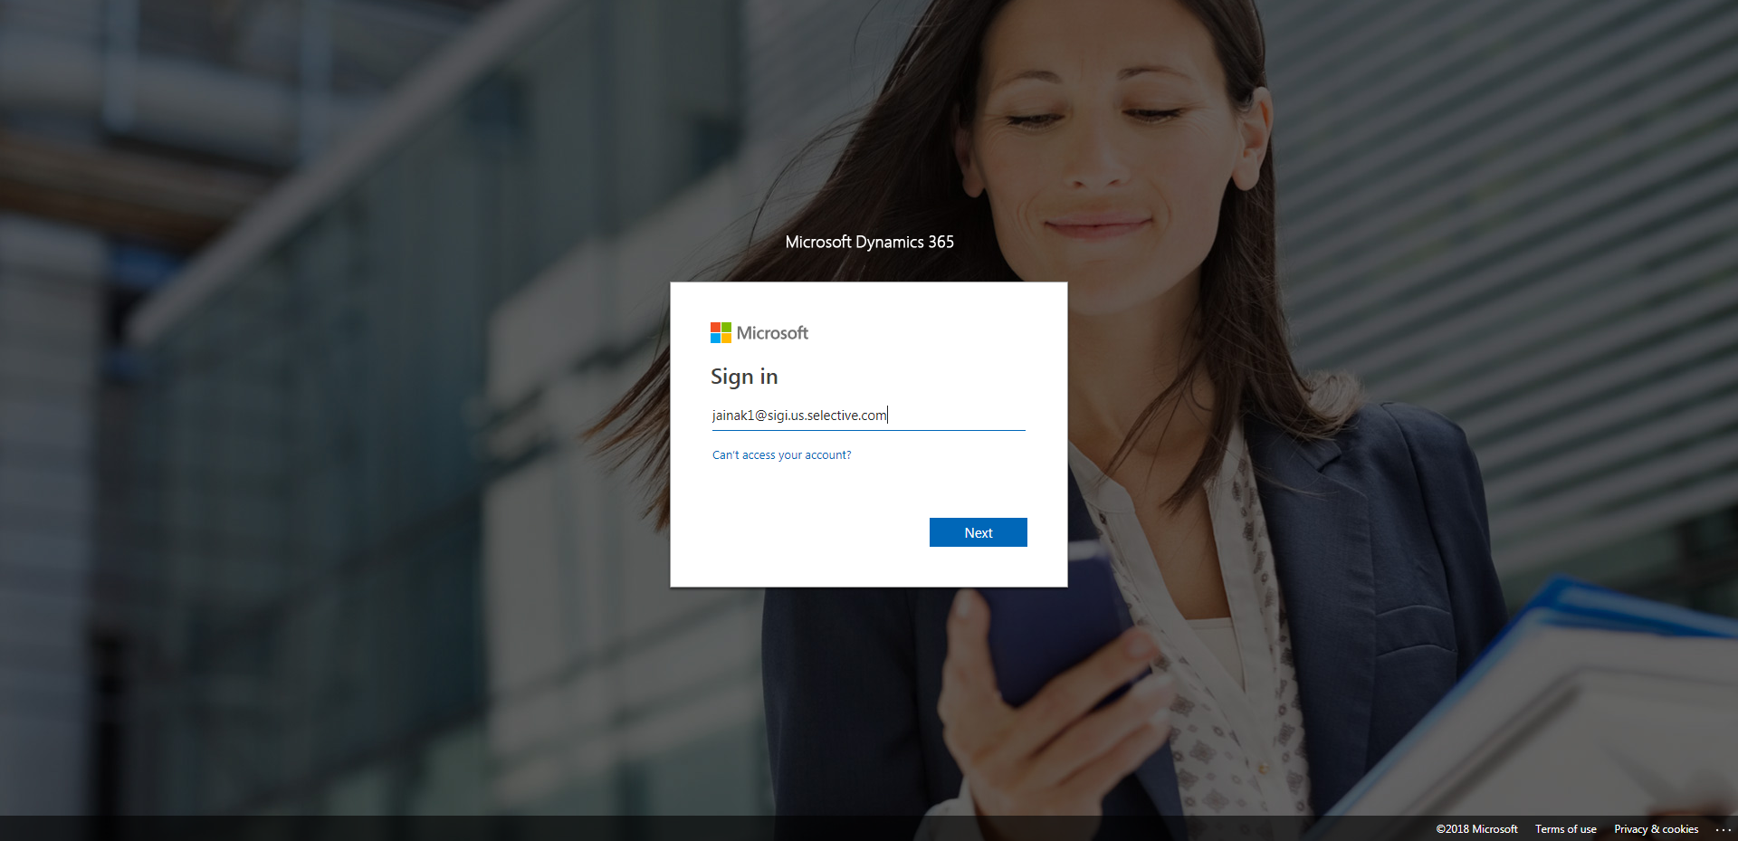

CaseManagement_CreationOfCase_Instance23_03-Aug-2018_08-13-53_AM_MouseClickActionMoveToElementBycssSelectoranavcases.png

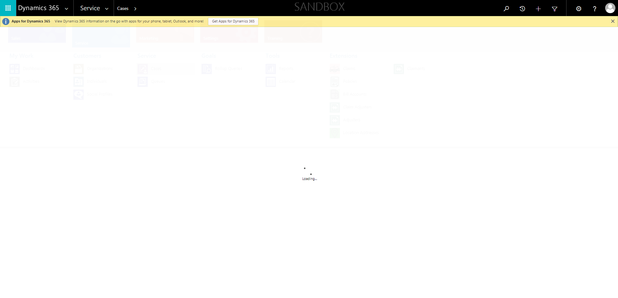

CaseManagement_CreationOfCase_Instance23_03-Aug-2018_08-13-47_AM_SingleSignOn.png

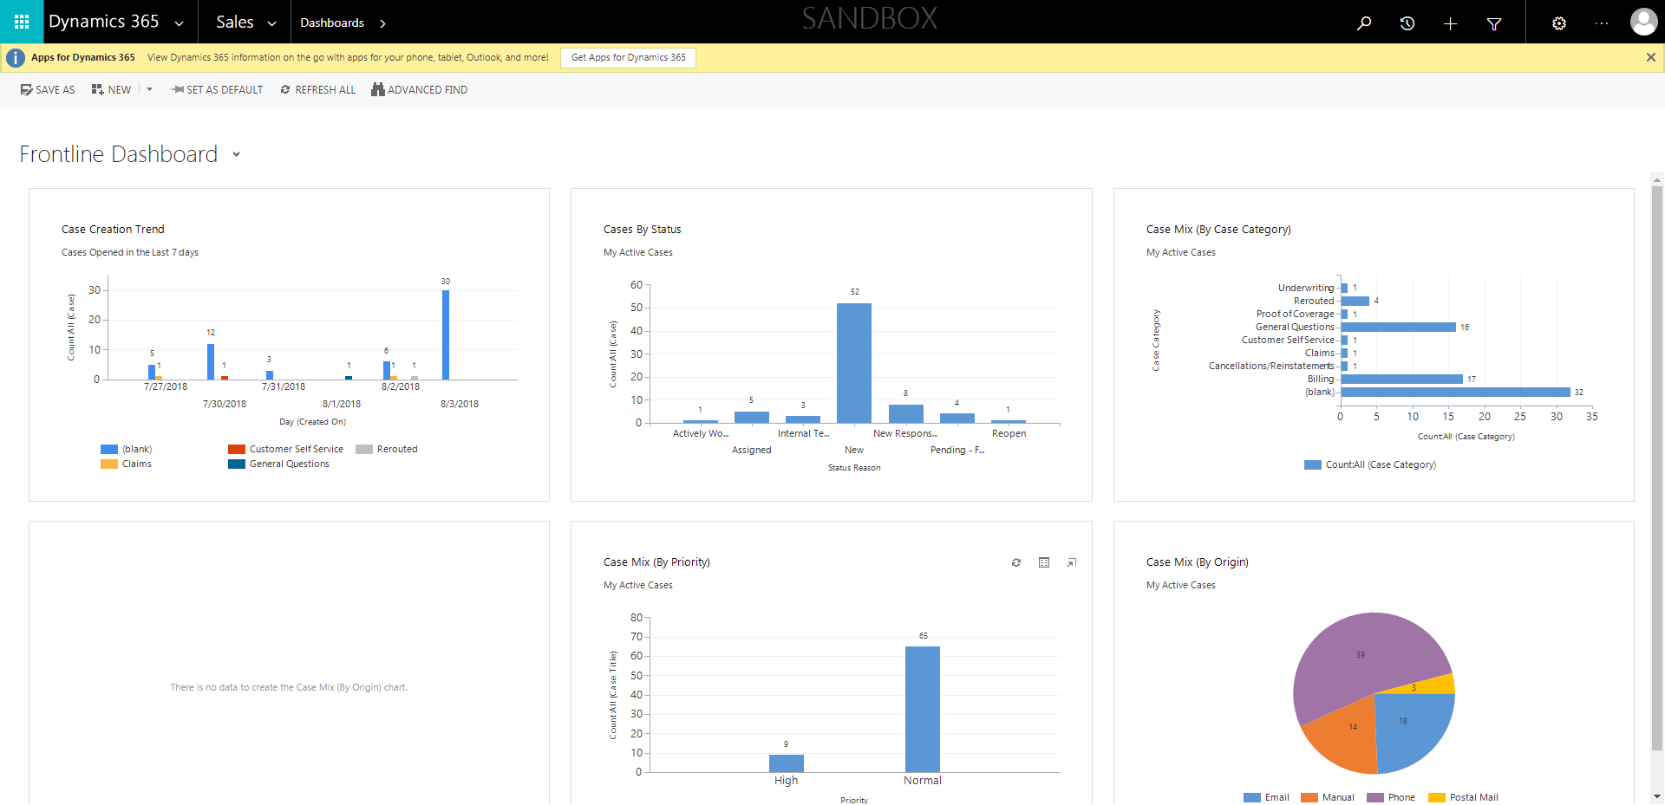

CaseManagement_CreationOfCase_Instance23_03-Aug-2018_08-13-52_AM_MouseClickActionMoveToElementByxpathimgaltServiceparentspan.png

